Web applications deployment guide

Version 0.1

[Date]

#### 

# Application Deployment guidelines

According to the adapted policy application deployment guidelines will mainly effect Admin and developers roles

Which is as follows:

## Guidelines to Admins

1. Must deploy all deployments on Staging first
2. Do not accept any deployment files if there is no release notes and there is no Team Foundation Server (TFS) entry for change notes.
3. If this is new deployment there must be release notes sent by the developer
4. **All production deployment approval is required from Head of Applications Development.**
5. Production deployment must be after 3:30 PM in other words no Production deployment with in the working hours.
6. Upon getting the confirmation of deployment on stage, developer can request the Production deployment only then the solution deployment for Production should be proceed.
7. Before deployment on production, Admin should extract the solution as a backup in case the developer request to revert the solution to previous build or version.
8. In case of exception and urgency or any critical circumstances where developer request the Production deployment with in working hours developer must provide the approval from higher management of i.e. Managers of business and technical team.
9. **Approval is required from Head of Applications Development to share any files from server to developer or any, connection string should be removed while sharing the web.config**

## Guidelines to Developers

1. Must not send any deployment files if there is no release notes and there is no Team Foundation Server (TFS) entry for change notes.
2. Must not send huge deployment files, which cause issues on the servers. File size should be within acceptable range otherwise consider changing the web application design. IIS team recommends not exceeding the size above then 100 MB. We highly recommend sending files using Dropbox or similar services to avoid email attachments.
3. Prior to moving to Production, developer must test each deployment on Stage first.
4. After testing the developer must confirmed the deployment in order to move the same solution for Production
5. **In case sending different package for production, must specify the reason on release notes.**
6. After the Production deployment, acknowledged developer must check and confirm the deployment.
7. Developer must provide prerequisites needed
8. Developer must provide detailed deployment steps
9. Developer must provide how to validate deployment how to make sure that package was deployed successfully
10. Developer must provide the source and target URLs
11. Developer must provide the related changes in the configuration files if required.

## Deployment Process

Deployment process starts from developer who send the request via sending email attachments or with download links, developer also provide the Team Foundation Server (TFS) entry where he describes the about the what changes and issues/bugs it fixes in the release , if it new release he or she will provide full detailed document for the release notes in TFS.

Every new deployment must be approved manager, Upon receiving the deployment request from the developer, IIS admin check the approval status if the deployments is new he get the approval from the manager if its existing he proceeds to Staging deployment once deployed he sent the acknowledgement to developer by replying the email.

Upon receiving the deployment confirmation from admin, developer check the website and tests that whether the desired changes has been reflected in the solution and desired state or results has been achieved. After testing, he or she send the confirmation to the admin and could request to proceed for Production deployment.

Upon receiving the request admin take the backup of the current solution, proceed for the production once deployment has done then admin check the site is working fine and send the deployment confirmation to developer.

Upon receiving the confirmation from admin, developer check the Website and test the solution and confirm back the Admin through replying email if the desired state or results has been achieved on production environment.

Afterwards the site URL has sent to Tester for quality assurance (QA) to testers.

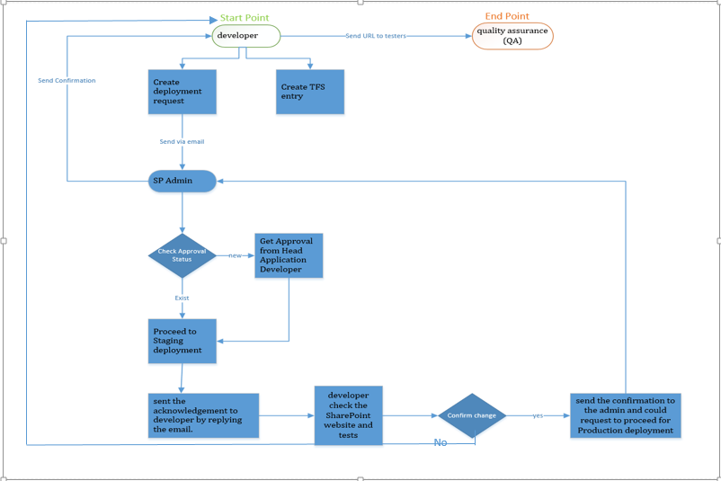

## General Deployment Policy

We have to schedule routine server maintenance, which is very important to keep the environment healthy, stable & available. Please share your future deployment plan with us ASAP, so we can schedule the maintenance in a different time slots.

As long as you have Development and/or Pre-Staging environment we are kindly requesting you to deploy the package there first and request the stakeholders to test initially and upon getting approval from stakeholders you can send it to us to deploy it on Stage 🡺 Prod.

In addition, we are requesting to keep the maximum 2 Major deployment per week due to same above reasons because each major deployment is causing effect on SharePoint farm in terms of stability and availability.

* **Major Deployment ( 2 Maximum Per week – should be scheduled at least one week minimum one week earlier) :**
* **Minor Deployment ( 1 Maximum per day – should be scheduled minimum 1 day earlier)**

Please if you have more than one project deployment at same time, please prioritize it based on your business needs, as we cannot install them in parallel.

Please note that our working hours are 8.00am until 5.00pm and we are accepting deployment requests max by 1PM for Stage or Production.

Stage Deployment will be done on same day and time if no other tasks are in Que and we will try our best to get back to you in same day before official working hours.

For Production Deployments, they will be started after 3.30pm and depends on number of WSPs; the whole process will took time accordingly. If you want to go live on same day then send us WSPs by 12PM for stage deployment so you can get our early response for validation before moving them to production. These all aspects should be covered in your release-planning document as requested above.

Only items created with TFS will be entertained. The format of TFS task should be like “Deployment-DD-MM-YYYY 🡺 Subject Line “and provided with release notes properly written in English.  Upon confirmation of deployment in (Stage or Production), please close the task as we are expecting from you to accept the work done by us.